Q1)

#include <iostream>

using namespace std;

int main() {

int alpha = 40, beta = 80, gamma = 20, delta = 50, theta = 30, zeta = 100;

int addition = alpha + beta;

int subtraction = delta - theta;

int multiplication = gamma \* zeta;

int division = beta / alpha;

int modulus = delta % theta;

int increment = ++gamma;

int decrement = --zeta;

cout << "Addition: " << addition << endl;

cout << "Subtraction: " << subtraction << endl;

cout << "Multiplication: " << multiplication << endl;

cout << "Division: " << division << endl;

cout << "Modulus: " << modulus << endl;

cout << "Increment: " << increment << endl;

cout << "Decrement: " << decrement << endl;

return 0;

}

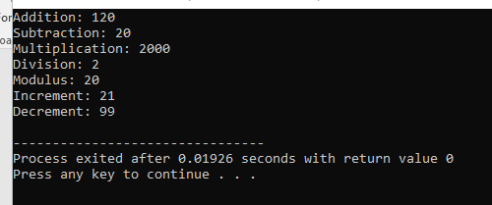

Q2)

#include <iostream>

using namespace std;

int main() {

int alpha = 40, beta = 80, gamma = 20, delta = 50, theta = 30, zeta = 100;

alpha += beta;

gamma -= delta;

theta \*= zeta;

beta /= gamma;

delta %= theta;

cout << "Alpha: " << alpha << endl;

cout << "Gamma: " << gamma << endl;

cout << "Theta: " << theta << endl;

cout << "Beta: " << beta << endl;

cout << "Delta: " << delta << endl;

return 0;

}

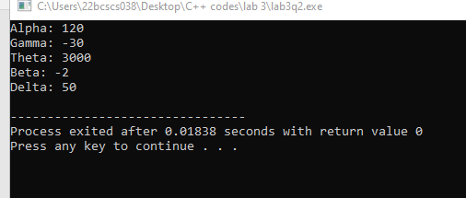

Q3)

#include <iostream>

using namespace std;

int main() {

int alpha = 40, beta = 80, gamma = 20, delta = 50, theta = 30, zeta = 100;

bool isEqual = (alpha == beta);

bool isNotEqual = (gamma != delta);

bool isGreater = (theta > alpha);

bool isLess = (zeta < beta);

bool isGreaterOrEqual = (delta >= gamma);

bool isLessOrEqual = (theta <= zeta);

cout << "Is Equal: " << isEqual << endl;

cout << "Is Not Equal: " << isNotEqual << endl;

cout << "Is Greater: " << isGreater << endl;

cout << "Is Less: " << isLess << endl;

cout << "Is Greater or Equal: " << isGreaterOrEqual << endl;

cout << "Is Less or Equal: " << isLessOrEqual << endl;

return 0;

}

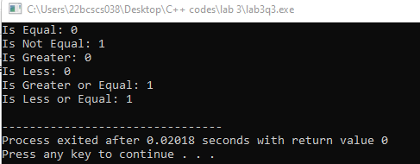

Q4)

#include <iostream>

using namespace std;

int main() {

int alpha = 40, beta = 80, gamma = 20, delta = 50, theta = 30, zeta = 100;

bool logicalAnd = (alpha > gamma) && (delta < zeta);

bool logicalOr = (beta >= theta) || (gamma != delta);

bool logicalNotAlpha = !(alpha > theta);

bool logicalNotBeta = !(beta < zeta);

cout << "Logical AND: " << logicalAnd << endl;

cout << "Logical OR: " << logicalOr << endl;

cout << "Logical NOT (Alpha): " << logicalNotAlpha << endl;

cout << "Logical NOT (Beta): " << logicalNotBeta << endl;

return 0;

}

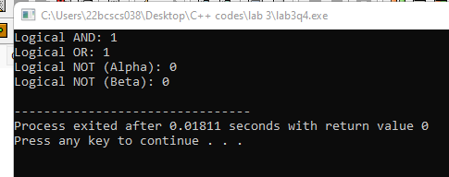

Q5)

#include <iostream>

using namespace std;

int main() {

int alpha = 40, beta = 80, gamma = 20, delta = 50, theta = 30, zeta = 100;

int bitwiseAnd = alpha & gamma;

int bitwiseOr = beta | delta;

int bitwiseXor = theta ^ zeta;

int bitwiseNotAlpha = ~alpha;

int bitwiseLeftShift = gamma << 2;

int bitwiseRightShift = zeta >> 1;

cout << "Bitwise AND: " << bitwiseAnd << endl;

cout << "Bitwise OR: " << bitwiseOr << endl;

cout << "Bitwise XOR: " << bitwiseXor << endl;

cout << "Bitwise NOT (Alpha): " << bitwiseNotAlpha << endl;

cout << "Bitwise Left Shift: " << bitwiseLeftShift << endl;

cout << "Bitwise Right Shift: " << bitwiseRightShift << endl;

return 0;

}

